# 2023 LDV Deliver 9 Specs, Features & Pricing | LDV Parramatta

Primary Keywords: ldv deliver 9 review

Secondary keywords:

ldv van review

ldv deliver 9 reliability

ldv deliver 9 height

why are ldv vans so cheap

ldv deliver 9 specs

ldv deliver 9 specifications

ldv deliver 9 owners manual pdf

ldv deliver 9 dimensions

ldv deliver 9 lwb high roof dimensions

ldv deliver 9 price

ldv deliver 9 lwb high roof

ldv deliver 9 lwb mid roof

ldv deliver 9 interior

ldv deliver 9 towing capacity

ldv t60 engine specs

ldv deliver 9 for sale

Competitors:

<https://www.drive.com.au/showrooms/ldv/deliver-9/>

<https://www.productreview.com.au/listings/ldv-deliver-9-large-van>

<https://www.carexpert.com.au/car-reviews/2021-ldv-deliver-9-review>

Entity:

Class, body style, (Powertrain layout)Drive type, ENgine, Transmission, Dimension(LBH, Wheelbase and kerb weight), Safety, Price,

Outline:

**Intro**

The Deliver 9 is set to take on the larger van market weighing from 2.5 to 4.5 tonne. Inspired by its predecessors, [LDV G10](https://www.ldvparramatta.com.au/new-vehicles/ldv-g10-van/) & [LDV V80](https://www.ldvparramatta.com.au/new-vehicles/ldv-v80-van/), the overall design has been inspired by the European based architectures. Tech & safety-wise, the range is leaps ahead.

The first impression we got is that "It's Big!" Compared to G10 & V80's, the exterior puts out a bold muscular representation.

Check out the complete video presentation of the Deliver 9 organized by [CarAdvice](https://www.caradvice.com.au/) below. If you are the one who loves visual presentation more, then we got you covered.  
View the full 360' video test-drive provided by our partner CarAdvice below⏬

Specs

Dimensions

Boot Space

Cargo and Interiors

Engine

Interior

Engine

Colors

Fuel COnsumption

Wheel size

Technology and features

Accessories

Safety

Price

Warranty and Servicing

Reviews

## Existing Content:

## **The all-new** [**2023 LDV Deliver 9**](https://www.ldvparramatta.com.au/new-vehicles/ldv-deliver-9-large-van/) **is available at** [**LDV Parramatta**](https://www.ldvparramatta.com.au/) **for sale.**

We have compiled the core [LDV Deliver 9 Large Van](https://www.ldvparramatta.com.au/new-vehicles/ldv-deliver-9-large-van/) features, specs that could help you decide. This big van delivers a wide range of amazing technology features that we have never seen in a van before. It truly stands out to its bold statement, "The Smart Van That Delivers More." Let's find out what this big boy has to offer technical wise.

## LDV Deliver 9 features

## **Overview**

The Deliver 9 is set to take on the larger van market weighing from 2.5 to 4.5 tonne. Inspired by its predecessors, [LDV G10](https://www.ldvparramatta.com.au/new-vehicles/ldv-g10-van/) & [LDV V80](https://www.ldvparramatta.com.au/new-vehicles/ldv-v80-van/), the overall design has been inspired by the European based architectures. Tech & safety-wise, the range is leaps ahead.

The first impression we got is that "It's Big!" Compared to G10 & V80's, the exterior puts out a bold muscular representation.

Check out the complete video presentation of the Deliver 9 organized by [CarAdvice](https://www.caradvice.com.au/) below. If you are the one who loves visual presentation more, then we got you covered.  
View the full 360' video test-drive provided by our partner CarAdvice below⏬

## **Cargo & Payload**

In terms of [payload](https://www.whichcar.com.au/car-advice/towing-weights-explained), the Deliver 9 kicks off at 1500kg for the auto mid-roof/mid-wheelbase auto, rising to a maximum of 1670kg for the high-roof/long-wheelbase manual (30kg for auto).

All variants can tow up to 2800kg of braked trailer.

In the cargo area, there are eight sturdy-looking tie-down points, LED lighting and a rubberised floor. There’s a 1.2-metre sliding door (single only) and 180-degree opening barn doors at the rear, but these can be optioned to 236 degrees.

The LWB mid-roof variant can take two standard Australian pallets in the rear, has 10.97 cubic metres of space and a payload of 1670kg.

### **What is the cargo area dimensions of LDV Deliver 9 Large Van?**

The cargo area of the LDV Deliver 9 Large Van measures 3019 mm to 3413 mm in length, 1800 mm in width, and 1792 mm to 2014 mm in height.

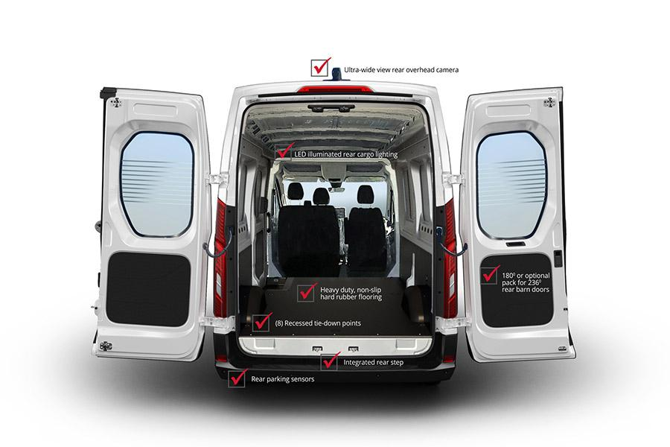

## 

## **Technology & Features**

The dashboard is dominated by a big central screen with Apple CarPlay and Bluetooth connectivity, but no Android Auto smartphone mirroring that we could see.

The dash looks well laid out and there are steering-wheel-mounted controls for the cruise control (adaptive in auto versions), phone and audio settings.

A rear parking camera with sensors come as standard, while a 10.1-inch infotainment screen offers Bluetooth and Apple CarPlay. Cruise control is also standard, but the optional automatic transmissions gain an adaptive cruise control system.

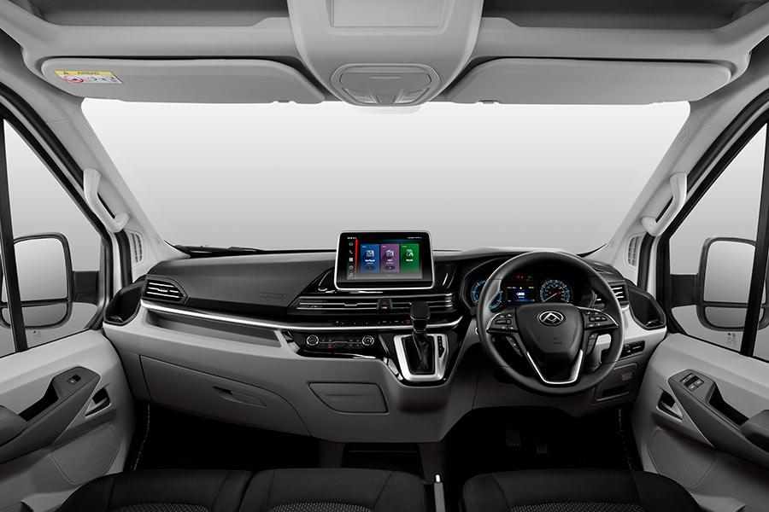

## **Engine**

All variants are powered by a new 2.0-litre four-cylinder turbo-diesel engine which has outputs of 110kW and 375Nm at 1500-2400rpm. It drives the rear wheels through a six-speed manual or six-speed automatic transmission.

The new engine replaces the previous 2.5 mills in the V80 which produced 100kW/330Nm.

### **What is the fuel consumption of LDV Deliver 9 Large Van?**

The LDV Deliver 9 Large Van has an average fuel consumption of 8.5 liters per 100 kilometers. With a fuel capacity of 80 liters, it offers a good balance between efficiency and capacity. Additionally, the LDV Deliver 9 has an impressive maximum payload capacity of 1500-1670 kg, making it suitable for handling substantial loads.

## **Dimensions**

|  | **MWB Mid Roof** | **LWB Mid Roof** | **LWB High Roof** |
| --- | --- | --- | --- |
| *Length (excluding camera)* | 5546mm | 5940mm | 5940mm |
| *Width (with mirrors)* | 2466mm | 2466mm | 2466mm |
| *Height (excluding camera)* | 2555mm | 2535mm | 2755mm |
| *Wheelbase* | 3366mm | 3760mm | 3760mm |
| *Turning circle* | 6.5m | 7.1m | 7.1m |
| *Gross vehicle mass* | 3800kg | 4000kg | 4000kg |
| *Front axle capacity* | 1680kg | 1780kg | 1790kg |
| *Rear-axle capacity* | 2120kg | 2220kg | 2210kg |
| *Payload* | 1500kg | 1670kg | 1640kg |
| *Cargo volume* | 9.66m³ | 10.97m³ | 12.33m³ |

### **What is the towing capacity of LDV Deliver 9 Large Van?**

The LDV Deliver 9 Large Van has a towing capacity of 2800 kg when braked and 750 kg when unbraked. This means it is capable of towing trailers or other loads up to those respective weights, providing versatility and flexibility for various transportation needs.

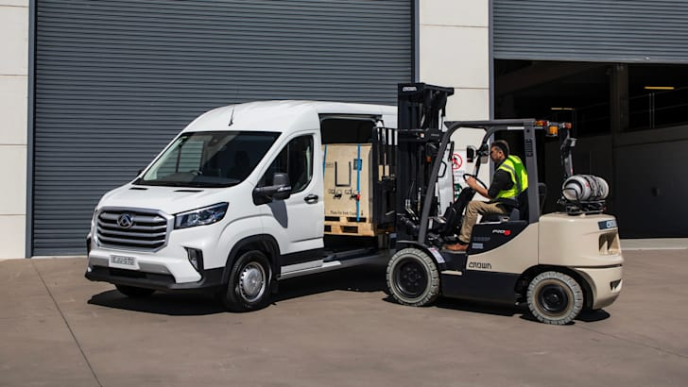

## **Interior**

* Air conditioning (front)
* Multifunction steering wheel
* Power windows (front)
* 4.2 inch LCD instrument cluster
* FM/AM/MP3 Player
* 8 way adjustable driver’s seat with fold down armrest
* Bench seat which fits two passengers. Built in under seat storage.
* Fold down middle passenger seat back with cup and laptop holder
* Overhead storage compartments
* Driver and passenger deep door pockets
* Two USB ports
* Apple CarPlay®
* Bluetooth
* 10.1 inch touch screen entertainment system

## **Safety**

Safety features include autonomous emergency braking (AEB), lane departure warning, Bosch stability control, six airbags and a reversing camera. Driver-assist systems from Bosch offers stability control and hill-hold, while six airbags (including double curtain bags) and four rear view sensors are standard, while a $1500 option pack provides lane change assist, blind-spot monitoring, keyless entry and rear doors that open out at 236 degrees.

## **Price Range**

The price of the LDV Deliver 9 van ranges from $44,990 to $49,490 Driveaway. It is available in three variants: Mid Wheel Base/Mid Roof, Long Wheel Base/Mid Roof, and Long Wheel Base/High Roof.

Here's the detailed price for LDV Deliver 9 Large van:

| LDV Deliver 9 Van | **Retail Price From\*** | **ABN Holder Price From\*** |
| --- | --- | --- |
| Mid Wheel Base / Mid Roof |  |  |
| Auto | $47,358 Driveaway | $44,990 Driveaway |
| Long Wheel Base / Mid Roof |  |  |
| Manual | $46,306 Driveaway | $43,990 Driveaway |
| Auto | $48,937 Driveaway | $46,490 Driveaway |
| Long Wheel Base / High Roof |  |  |
| Auto | $51,042 Driveaway | $48,490 Driveaway |

## 

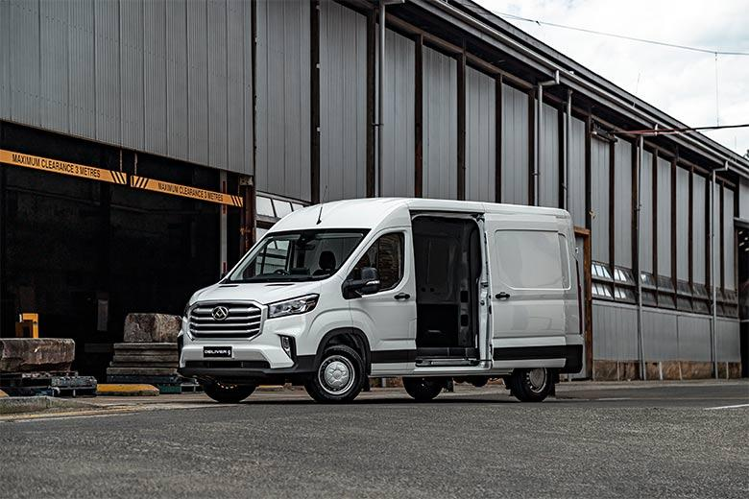

[View Price guide of LDV Vehicles](https://www.ldvparramatta.com.au/blog/ldv-vehicles-price-guide/6114/)

## **Warranty & Servicing**

All new LDV Deliver 9 vans come with a comprehensive factory-backed 3 year/160,000km (whichever occurs first) warranty. You’ll also have full visibility with capped pricing for scheduled services up to 3 years or 95,000 km (whichever occurs first).

LDV is committed to delivering you complete peace of mind when purchasing your new LDV. With our Capped Price Servicing Program, you will know upfront the maximum cost of your Deliver 9's scheduled services for up to 3 years or 95,000 km (whichever occurs first) at [LDV Service Centre](https://www.google.com/maps/place/LDV+Service+Centre/@-33.8164555,151.0198215,15z/data=!4m2!3m1!1s0x0:0x4872d084a42e6572?sa=X&ved=2ahUKEwj8xpzvqMLsAhXpyjgGHaPtAxwQ_BIwCnoECBQQBQ). (*T&Cs apply)

So, would you like to check out this big toy in person? You can visit our showroom located at Parramatta, NSW and test-drive it yourself. Alternatively, please call us at (02) 9682 2100 to book an appointment. We hope to see you soon.

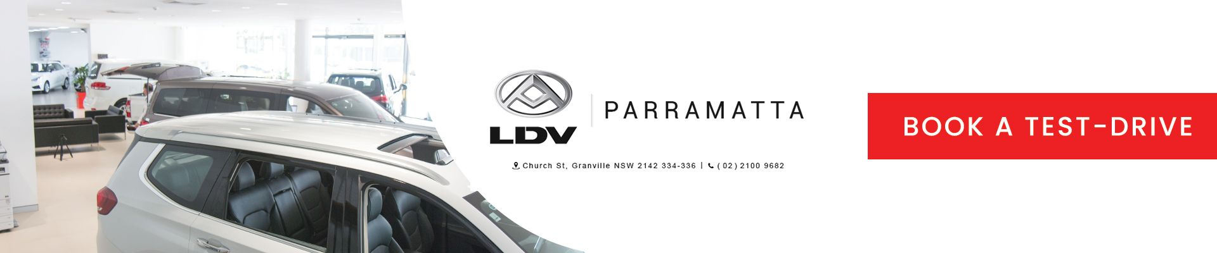

LDV Deliver 9 is a large-sized commercial van suitable for businesses of all sizes. In this in-depth review of [**LDV Deliver 9 Large Van**](https://www.ldvparramatta.com.au/new-vehicles/ldv-deliver-9-large-van/), we are going to unpack everything about this Large Van and learn about its features, specifications, engine, dimensions, interiors and more.

Let’s dive into it.

## LDV Deliver 9 Specifications

Mid Wheel Base (Mid Roof) / Long Wheel Base (Mid Roof) / Long Wheel Base (High Roof)

### 

### **Engine Specifications**

* 2.0L turbo diesel Euro V engine
* Eco and power mode
* Turbocharger and intercooler
* Polymer skirted pistons
* 4 cylinders (16 valves)
* 1996cc total displacement
* 108kW @ 3500rpm
* 375Nm @ 1500-2400 rpm

The Deliver 9’s engine is designed to balance power, fuel economy, and emissions. The Eco mode helps conserve fuel by adjusting the engine’s performance, while the Power mode provides more power when needed. The turbocharger and intercooler help to improve the engine’s performance by providing more air to the combustion chamber. The polymer skirted pistons help to reduce friction and improve fuel economy. The 4 cylinders with 16 valves allow for more efficient combustion, which also helps to improve fuel economy and emissions.

The Deliver 9’s engine is a reliable and efficient powerplant well-suited commercially. It provides a good balance of power, fuel economy, and emissions and is available with a choice of manual or automatic transmissions.

#### **What is the fuel consumption of LDV Deliver 9 Large Van?**

The LDV Deliver 9 Large Van has an average fuel consumption of 8.5 litres per 100 kilometres. With a fuel capacity of 80 litres, it offers a good balance between efficiency and capacity. The LDV Deliver 9 also has an impressive maximum payload capacity of 1500-1670 kg, making it suitable for handling substantial loads.

### 

### **Cargo & Payload**

In terms of [payload](https://www.whichcar.com.au/car-advice/towing-weights-explained), the Deliver 9 kicks off at 1500kg for the auto mid-roof/mid-wheel base auto, rising to a maximum of 1670kg for the high-roof/long-wheelbase manual and 1640kg for the high-roof/long-wheelbase auto.

The LDV Deliver 9 Large Van has a towing capacity of *2800 kg when braked and 750 kg when unbraked*. This means it can tow trailers or other loads up to those respective weights, providing versatility and flexibility for various transportation needs.

| LDV Deliver 9 Van | Mid Wheel Base (Mid Roof) | Long Wheel Base (Mid Roof) | Long Wheel Base (High Roof) |
| --- | --- | --- | --- |
| Payload (kg) | Auto: 1500 | Man: 1670 / Auto: 1640 | Man: 1640 / Auto: 1620 |
| Braked towing capacity (kg) | 2800 | 2800 | 2800 |
| Unbraked towing capacity (kg) | 750 | 750 | 750 |

The cargo area has eight sturdy-looking tie-down points, LED lighting, and a rubberised floor. There’s a 1.2-metre sliding door (single only) and 180-degree opening barn doors at the rear, but these can be optioned to 236 degrees.

The LWB mid-roof variant can take two standard Australian pallets in the rear, has 10.97 cubic metres of space and has a payload of 1670kg.

#### 

#### **What are the cargo area dimensions of LDV Deliver 9 Large Van?**

The cargo area of the LDV Deliver 9 Large Van measures 3019 mm to 3413 mm in length, 1800 mm in width, and 1792 mm to 2014 mm in height.

## 

## LDV Deliver 9 Dimensions and Variants

The LDV Deliver 9 large van is available in three variants: Mid Wheel Base (Mid Roof), Long Wheel Base (Mid Roof), and Long Wheel Base (High Roof).

The different variants of the LDV Deliver 9 large van are designed to meet the needs of different businesses and individuals. The Mid Wheel Base (Mid Roof) variant is a good option for businesses that need a van with a small footprint and a moderate cargo capacity. The Long Wheel Base (Mid Roof) variant is a good option for businesses that need a van with a larger cargo capacity. The Long Wheel Base (High Roof) variant is a good option for businesses that need a van with a huge cargo capacity.

The 2023 LDV Deliver 9 large van measures *5546 mm to 5940 mm in length, 24466 mm in width, and 2535 mm to 2755 mm in height.*

|  | **MWB Mid Roof** | **LWB Mid Roof** | **LWB High Roof** |
| --- | --- | --- | --- |
| *Length (excluding camera)* | 5546mm | 5940mm | 5940mm |
| *Width (with mirrors)* | 2466mm | 2466mm | 2466mm |
| *Height (excluding camera)* | 2555mm | 2535mm | 2755mm |
| *Wheelbase* | 3366mm | 3760mm | 3760mm |
| *Cargo volume* | 9.66m³ | 10.97m³ | 12.33m³ |

## 

## LDV Deliver 9 Interiors and Features

* Air conditioning (front)
* Multifunction steering wheel
* Power windows (front)
* 4.2-inch LCD instrument cluster
* 180-degree rear barn doors
* 8-way adjustable driver’s seat with fold-down armrest
* Bench seat which fits two passengers. Built-in under-seat storage.
* Fold down the middle passenger seat back with a cup and laptop holder
* Overhead storage compartments
* Driver and passenger deep door pockets
* LED-illuminated rear cargo lighting

### 

### **Infotainment Systems**

* FM/AM/MP3 Player
* Apple CarPlay® and Bluetooth connectivity
* 10.1-inch touchscreen entertainment system

## LDV Deliver 9 Exterior and Colors

The LDV Deliver 9’s exterior is a modern and stylish design that will appeal to a wide range of customers. The front end features a large grille, swept-back headlights, and a prominent bumper. The side profile is characterised by its muscular wheel arches and large windows. The rear end features a sloping tailgate, integrated taillights, and a chromed bumper.

The large windows provide excellent visibility, and the sloping tailgate makes loading and unloading cargo easy. The muscular wheel arches and large tires give the Deliver 9 a rugged appearance, while the chromed bumper adds a touch of luxury.

The LDV Deliver 9 is available in two exterior colours, Blanc White and Mica Blue, whereas the interior is available in Black Cloth Trim.

## 

## Safety Features of LDV Deliver 9

* Anti Skid Braking System (ABS)
* Electronic Stability Control (ESC)
* Brake Assist System (BAS)
* Hill Hold Assist (HHA)
* Adaptive Cruise Control (ACC) on automatic models,
* Standard Cruise Control (SCC) on manual models
* Driver and front passenger airbags
* Driver and passenger side airbags
* Double curtain airbag (first row)
* Reverse parking sensors (four)
* Wide view rear overhead camera

Find complete specifications of [LDV Deliver 9 Large Van here](https://www.ldvparramatta.com.au/new-vehicles/ldv-deliver-9-large-van/#specifications).

## 

## LDV Deliver 9 Price and Sale Availability

The LDV Deliver 9 van ranges from $44,990 to $49,490 Driveaway. It comes with a 3-year/160,000km Warranty and 3-year/160,000km Roadside Assist to ensure you can drive your van without any worries.

Related: [LDV Van For Sale:Discover New LDV Vans](https://www.ldvparramatta.com.au/blog/ldv-van-for-sale-discover-new-ldv-vans/5909/)

Here’s the exact price for LDV Deliver 9 Large vans:

| LDV Deliver 9 Van | **Retail Price From\*** | **ABN Holder Price From\*** |
| --- | --- | --- |
| Mid Wheel Base / Mid Roof |  |  |
| Auto | $47,358 Driveaway | $44,990 Driveaway |
| Long Wheel Base / Mid Roof |  |  |
| Manual | $46,306 Driveaway | $43,990 Driveaway |
| Auto | $48,937 Driveaway | $46,490 Driveaway |
| Long Wheel Base / High Roof |  |  |
| Auto | $51,042 Driveaway | $48,490 Driveaway |

## Also check out our ongoing [End Of Financial Year sale](https://www.ldvparramatta.com.au/special/).

## 

### **Why are LDV Vans So Cheap?**

LDV is a relatively new brand in Australia thatonly entered the Australian market in 2016. As a result, they are less well-known than some of the more established brands, such as Toyota and Ford. This lack of brand recognition allows LDV to offer their vans at a lower price.

Despite being less expensive, LDV vans are still a good value for money. They are well-built and reliable, and they come with an extended warranty. A strong dealer network also backs LDV vans so that you can get the necessary service and support.

If you are looking for a cheap van, LDV is an excellent option. They offer a wide range of vans, and a strong warranty and dealer network back them.

## 

## Final Verdict

**Pros:**

* Affordable (Good space-for-dollar ratio)
* Spacious interior
* Large cargo capacity
* Good fuel economy
* Long warranty
* Stylish exterior

**Cons:**

* Not as well-known as some of its competitors
* Not as many features as some of its competitors (Missing sunroof)

Overall, the LDV Deliver 9 is a good option for businesses and individuals looking for an affordable, spacious, and reliable van. It offers a good balance of features and price; an extended warranty backs it.

Why not visit our dealership or book an online appointment for a test drive and see how this Large Van suits your needs?

